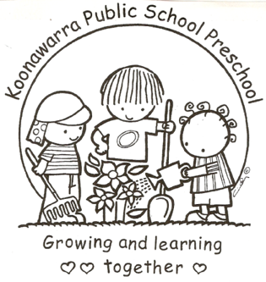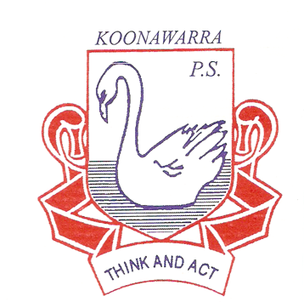
KOONAWARRA PUBLIC SCHOOL PRESCHOOL

(a) (iii) Water Safety
(Including water-based activities)

Forbes Street Woolloomooloo 2013
T: 9358 5335/6
F: 93571831
E: plunketstr-p.school@det.nsw.edu.au

Current | March 2018
Next Review | March 2019
Regulation(s) | Regulation 168 (2)(a)  Regulation 101  Regulation 103  Regulation 136
National Quality Standard(s) | Standard 2.1  Standard 2.2
Relevant DoE Policy and link | Student Health in NSW Public Schools: A summary and consolidation of policy PD/2004/0034/V01  Excursion policy PD/2004/0010/V07 -  Implementation document: Excursion Policy Implementation Procedures
Relevant School Procedure
DoE Preschool Handbook January 2016 | Preschool Handbook – Water Safety: page 45
Key Resources | Kidsafe NSW-Water Safety  Kids Alive- Do the five  Public Schools NSW: Risk Management Plans

- Water containers or water features that could be drowning hazards will be appropriately covered or inaccessible to children.

- Educators will more closely supervise children when they are using water in their play or watering the garden. If a container of water is to be taken into the sand pit area, educators will pay particular attention to this area.

- Educators and the children will empty any water containers immediately at the end of the play session, particularly larger trough-style containers.

- As part of the morning outdoor safety check, before the children arrive, educators will check no rain water has pooled in containers overnight.

- Taps will be fitted with safety locking devices so children can’t turn them on independently. Staff will ensure the tap is removed after use.

- Children will refrain from using their own drink bottles as a source water play.

- No hot water will be accessible to the children in the preschool, ie. The hot taps do not operate.

- Adults may not carry and consume hot drinks at all around the children. These are to be consumed in staff only areas such as the office and kitchen.

- A risk assessment will be conducted prior to any excursion taking place. If the venue has a body of water such as a lake or creek, the staff to child ratio will be increased.

