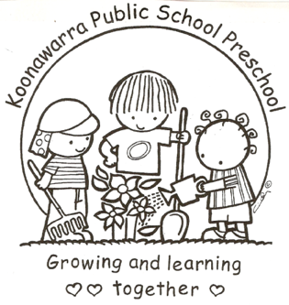
KOONAWARRA PUBLIC SCHOOL PRESCHOOL

(m) The acceptance and refusal
of authorisations
Forbes Street Woolloomooloo 2013
T: 9358 5335/6
F: 93571831
E: plunketstr-p.school@det.nsw.edu.au

Current | July 2018
Next Review | July 2019
Regulation(s) | Regulation 92  Regulation 93  Regulation 99  Regulation 101  Regulation 102  Regulation 160  Regulation 168
National Quality Standard(s) | Standard 2.1  Standard 2.2  Standard 7.1
Relevant DoE Policy and link | Public Schools NSW Preschool – Obtaining parents’ authorisation and consent procedures  Public Schools NSW: Enrolment of Students in NSW Government Schools: A Summary and Consolidation of Policy  Public Schools NSW: Application to enrol in a NSW government preschool  Public Schools NSW: Enrolment in a Department Preschool procedures  Public Schools NSW: Excursions Policy  Public Schools NSW: Excursions Policy Implementation Procedures  Public Schools NSW: Excursions overview and key steps  Student Health in NSW Public Schools: A summary and consolidation of policy PD/2004/0034/V01  Public Schools NSW: Administering prescribed medication at school
DoE Preschool Handbook January 2016 | Department of Education Preschool Handbook:  Wellbeing, p. 39-40
Key Resources | ACECQA Medication Record

- Parents’ authorisations or refusals will be collected as part of the enrolment process and stored with the child’s enrolment form.

- Authorisations must be accepted or refused in writing by the parent/carer. This is done on pages 12 and 13 of the Application to enrol in a NSW Government preschool form.

- Parents who notify educators that their child needs to be administered prescribed medication will be requested to complete the relevant form, authorising educators to administer the medication. Educators will waive compliance where a child requires emergency medical treatment for conditions such as anaphylaxis or asthma. The service can administer medication without authorisation in these cases, provided they contact the parent/guardian as soon as practicable after the medication has been administered.

- A child will not be allowed to attend an excursion without parental consent.

- All documentation relating to authorisations must contain the child’s name, date and signature of the child’s parent/guardian, or nominated contact person as noted on the enrolment form.

- The school principal can exercise the right of refusal if written or verbal authorisations do not comply.

