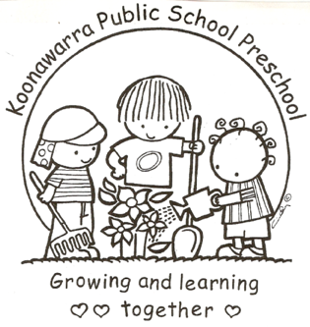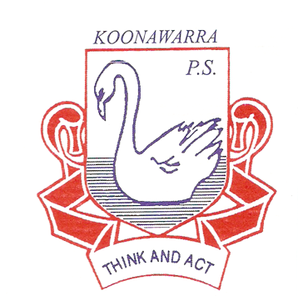
KOONAWARRA PUBLIC SCHOOL PRESCHOOL

(a) (ii) Sun Protection

Current | March 2018
Next Review | March 2019
Regulation(s) | Regulation 168 (2)(a)
National Quality Standard(s) | Standard 2.1  Standard 2.2
Relevant DoE Policy and link | Student Health in NSW Public Schools: A summary and consolidation of policy PD/2004/0034/V01-  Sun Safety in Public Schools
Relevant School Procedure | Sunsmart Policy and Procedures
DoE Preschool Handbook January 2016 | Wellbeing, page 42  Wellbeing Appendix 2.8 Sun Protection
Key Resources | Public Schools NSW: Supporting students during hot weather  Public Schools NSW: Sun Safety Risk Management support documents  Sun Safety in Public Schools  The Cancer Council NSW SunSmart childcare: A guide for service providers, Sydney, 2008.  Policies in practice: Sun protection– Early childhood resource hub
Forbes Street Woolloomooloo 2013
T: 9358 5335/6
F: 93571831
E: plunketstr-p.school@det.nsw.edu.au

- Our preschool outdoor spaces will include adequate shaded areas to protect children from overexposure to ultraviolet radiation from the sun. At the present time we are sourcing a cover for the new sandpit. The aim is to install this during 2018.

- During the summer months from October to March on extremely hot days with high UV all outdoor activities will be placed in shaded areas. We will also vary normal teaching programs e.g. bringing the children inside in extreme conditions

- In the months from October to March, sun protection (hats, protective clothing, sunscreen and shade) is needed and consideration will be given to the amount of time children spend outdoors between 11 am and 3 pm.

- In the months from April to September, sun protection is needed when children are outside between 10 am and 2 pm. Outdoor activities can be scheduled to take place at any time.

- Sun protection will be included in the preschool’s learning programs. When parents / carers enrol their children, they will be verbally informed about the preschool’s sun protection procedures. At enrolment, they will be encouraged to discuss any special requirements their child may have with sun protection (including allergies) with our preschool teacher.

- Sun safety will be promoted through and the preschool’s provision of hats for every child. Hats are washed at the end of each attendance pattern.

- During routines, opportunities are used to discuss sun safe practices with the children e.g. when putting on sunscreen educators talk to the children about why this is needed.

- Staff and children are all encouraged to wear sun safe hats that protect their face, neck and ears. Baseball caps are not recommended.

- When outdoors staff and children will be encouraged to wear shirts with sleeves. Children will be discouraged from wearing singlets, sleeveless and midriff tops. T shirts will be provided to cover singlet tops.

- Parents to apply sun screen on their children before they start Preschool. If necessary at the beginning of the day all staff and children will apply SPF 30+ broad spectrum water resistant sunscreen. This will be reapplied 20 minutes before outside activities.

- At regular intervals posters are displayed in prominent positions in the Preschool. Copies of this policy are available to all key stakeholders.

