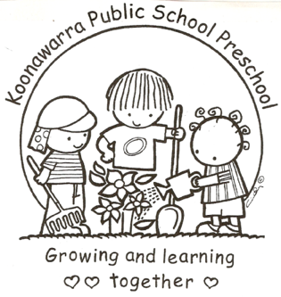
KOONAWARRA PUBLIC SCHOOL PRESCHOOL

(a)(v) Sleep and Rest
Forbes Street Woolloomooloo 2013
T: 9358 5335/6
F: 93571831
E: plunketstr-p.school@det.nsw.edu.au

Current | 25/7/18
Next Review | 25/7/19
Regulation(s) | R.81, R168
National Quality Standard(s) | Element 2.1.2 - Each child’s comfort is provided for and there are appropriate opportunities to meet each child’s need for sleep, rest and relaxation.
Relevant DoE Policy and link | Student Health in NSW Public Schools: A summary and  consolidation of policy  https://education.nsw.gov.au/policy-library/policies/student-health-in-nsw-public-schools-a-summary-and-consolidation-of-policy
Relevant School Procedure
DoE Preschool Handbook January 2016 | Wellbeing, page 36
Key Resources

- Children will be encouraged to recognise their need for rest through the provision of quiet spaces.
- Terms 1,2,3 all children will be provided with a bed and encouraged to lay quietly and rest.
- Term 4 children are provided with quiet activities in the period after lunch.
- If a child requires rest or is feeling unwell, at any time throughout the day, quiet areas with cushions and sheets, are always available and can be accessed by the children if necessary.
- The outdoor environment has been designed to provide quiet areas for children.
- If a child falls asleep parents and/or carers will be informed.

