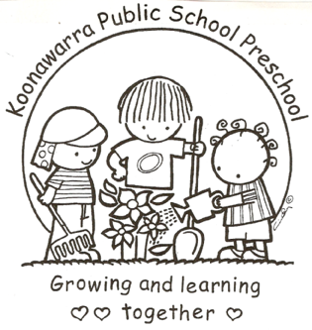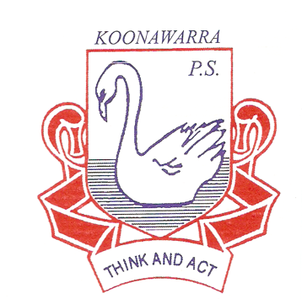
KOONAWARRA PUBLIC SCHOOL PRESCHOOL

(a) (i) Nutrition, Food and Beverages, Dietary Requirements

Current | May 2018
Next Review | May 2019
Regulation(s) | Regulation 168 (2)(a)  Regulation 77  Regulation 78
National Quality Standard(s) | Standard 2.1  Standard 2.2
Relevant DoE Policy and link | Nutrition in schools policy  Student Health in NSW Public Schools: A summary and consolidation of policy PD/2004/0034/V01-  Anaphylaxis Procedures for Schools - Wellbeing and learning  Allergy and Anaphylaxis Management within the Curriculum P-12 Procedures (PDF)
Relevant School Procedure
DoE Preschool Handbook January 2016 | Wellbeing, p.34
Key Resources | Department of Education Preschool Handbook  Get up and grow: Healthy eating and physical activity for early childhood resources. Australian Government Department of Health  Munch and Move. Healthy Kids: eat well, get active  Department of Primary Industries NSW Food Authority  Promoting healthy eating and nutrition in education and care services – Early childhood resource hub  Anaphylaxis guidelines for early childhood education and care services – Early Childhood Education and Care  Guidance in completing the Risk Management Plan Proforma: managing exposure to allergens - Health and Safety Directorate - intranet  Risk management: sample plan – Health and Safety Directorate – intranet  ASCIA Information for Schools and Childcare  ASCIA Action Plans for Anaphylaxis and Allergic Reactions.
Forbes Street Woolloomooloo 2013
T: 9358 5335/6
F: 93571831
E: plunketstr-p.school@det.nsw.edu.au

Food and nutrition
- When a child with a known food allergy enrols, the preschool teacher will consult with the child’s family to develop a risk minimisation plan to avoid exposure to known allergen.

- All preschool children will be exposed to healthy eating practices.

- The preschool program will promote good nutrition and help children and parents to develop good food habits. In addition, staff and children will discuss the relationship between nutrition, physical fitness and good health.

- Preschool educators will provide a positive and healthy eating environment. They will act as role models, maintain good personal nutrition and encourage independence and social skills at meal times. Both educators will sit and eat with the children during meal times.

- Children will be encouraged to eat fruit at morning tea and their sandwich first at lunch.

- The preschool will provide nutritional information to parents. This may be through the Family Handbook and posters. This can help encourage parents to send food to preschool that is nutritionally balanced.

- No chocolate, or chocolate products, potato chips, lollies, sweet biscuits or cakes will be allowed to be consumed at preschool. If these items are provided staff will discuss with parents a healthy alternative. EXCEPTION: When a child celebrates a birthday, an allowance is made for the child to share this experience and a cake with their preschool friends. (This ensures the child is able to celebrate their importance with others and feel a sense of belonging, EYLF).

- Food will not be used as a punishment or reward.

- Drinking water will be available to the children at all times. Each child has their own drinking bottle labelled with their name. The drink bottles are washed weekly at the end of the children’s time at preschool.

- Special dietary needs (including allergens) will be displayed in food preparation areas. If the Preschool is notified of a severe food allergy such as peanuts, we will endeavour to eliminate the allergen food.

- Staff also need to consider the special dietary requirements of children from diverse cultural and religious backgrounds.

- Posters will be displayed in the bathroom to ensure children are aware of correct handwashing routines. Frequent discussions are had with children in regard to handwashing before eating.

- When providing cooking activities with the children the food and drinks must be nutritious and adequate in quantity, taking into account any dietary requirements of the children.

Food preparation and handling

- Any area where food is prepared or stored will be kept clean and good hygiene and safety practices reinforced throughout all cooking activities.

- A sign notifying parents / carers of ice pack requirements is displayed in the foyer. Children’s lunches are stored in their bags. Carers provide a freezer bag with an ice pack to maintain the safe storage of their children’s food. The above strategies for safe storage of food in lunch boxes are sourced from Staying Healthy and ACECQA.

- To reduce the risk of exposure to food allergens, staff in the preschools will follow the advice in Anaphylaxis Procedures for Schools.

- The following procedures are a good guide for staff when preparing and handling food:

- wash and dry hands before and afterwards
- do not handle food when ill
- cover and seal any cuts or sores
- wash fruit and vegetables thoroughly
- replace cutting boards and washing-up cloths on a regular basis
- use tongs or spoons when serving food
- keep food covered until served
- ensure children are not in the kitchen during meal preparation.

- A list of children and their reactive foods will be updated regularly and displayed in the kitchen and Relief Teacher Handbook so that it can be seen by all adults involved in the program. This is especially important when children with anaphylaxis are attending the preschool.

- If applicable, a notice will be hung in the foyer stating that there is a child who has been diagnosed at risk of anaphylaxis to a specific food(s). This will done anonymously in order to protect the rights of the individual child but will ensure other families do not pack this food(s) in their child’s lunchbox.

