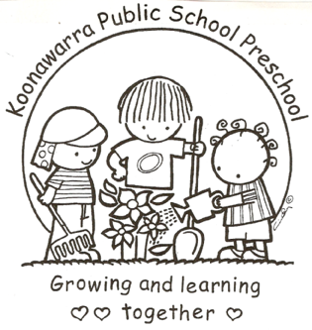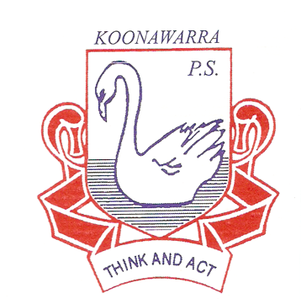
KOONAWARRA PUBLIC SCHOOL PRESCHOOL

(l) Governance

Current  Forbes Street Woolloomooloo 2013  T: 9358 5335/6  F: 93571831  E: plunketstr-p.school@det.nsw.edu.au | July 2018
Next Review | July 2019
Regulation(s) | Regulation 118  Part 4.7 Leadership and Service Management:  Regulations – 158-185  Regulation 168
National Quality Standard(s) | Standard 7.1  Standard 7.2
Relevant DoE Policy and link | Public Schools NSW: Leading and Managing the Schools Policy  Public Schools NSW: Information Security Policy  Public Schools: Privacy Code of Practice  Public Schools NSW: Functional Retention and Disposal Authority: FA387  Public Schools NSW: Applying Appropriate Security to Records: What Should and Should Not be Regarded as "Confidential" Records? DET Records Management Unit Advice 16  Public Schools NSW Code of Conduct Policy  Public Schools NSW: Code of Conduct Procedures
Relevant School Procedure
DoE Preschool Handbook January 2016 | Access, pages 15-17  Staffing, pages 56, 60-61
Key Resources | Public Schools NSW: School disposal procedures information  Public Schools NSW: Business Management – Records management for schools  Public Schools NSW Privacy Bulletins
The Principal
- In keeping with Leading and Managing the School Policy (see link above) ‘the principal occupies the pivotal position in the school and is accountable for leadership and management consistent with State legislation and the policies and priorities of the NSW Government”’

- The principal has overriding responsibility for the supervision of the preschool however he/she may delegate the supervision of the preschool education program to an executive staff member.

- The Nominated Supervisor, Responsible Person and Educational Leader of Koonawarra Preschool is the School Principal. In the event that the Principal is not present in the school the Relieving Principal resumes these responsibilities.

Nominated Supervisor
- The National Law requires all children’s services to have a Nominated Supervisor.

- The Nominated Supervisor requires knowledge of the Education and Care Services National Regulations and is responsible for the overall supervision of the preschool, the program of activities, and any other specific matters relating to the preschool.

- Under the regulations the Nominated Supervisor position is able to be designated as a ‘class of person’. In Departmental preschools this designation is the principal. When the principal is absent the person relieving becomes the Nominated Supervisor.

- The Nominated Supervisor is not required to be in attendance at the preschool at all times.

- Information on the Nominated Supervisor needs to be displayed in a prominent position in the preschool. (Regulation 173)

Educational Leader
- Regulation 118 states that each preschool must have an Educational Leader to lead the development and implementation of the educational program.

- The principal as leader of the school will be the Educational Leader.

- The principal may choose another member of staff, for example the supervisor of the preschool, to support this role.

- Details of the Educational Leader also need to be displayed in a prominent position in the preschool.
Responsible person in charge
- This role is also assigned to the principal.

- Its purpose is to ensure that there is always a responsible person on the school premises who is in charge of the preschool.

- When the principal is absent the preschool staff should be notified of the name of the person replacing the principal.

Records about children
- The preschool will keep detailed and current records for each individual child attending the preschool.
- Much of this information is obtained from the Application to enrol in a NSW Government preschool and Koonawarra’s Preschool’s ‘Additional Information’ form;
- Records which contain personal information about a child are considered confidential and are kept in a secure and private area of the preschool.
- In order to deliver quality programs to all children enrolled in Preschool, it is necessary to obtain a range of personal information.
- It is the responsibility of the principal and preschool teacher to ensure that this information is accurate, confidential and used appropriately.
- Parents from culturally and linguistically diverse backgrounds should be offered interpreter assistance in obtaining this information if required.
- Parents will have access to their own child’s records on request to the teacher.
- The Principal and Preschool Teacher ensures that information kept in a record under these Regulations is not divulged or communicated, directly or indirectly, to another person other than:
  - to the extent necessary for the education and care or medical treatment of the child to whom the information relates; or
  - a parent of the child to whom the information relates, except in the case of information kept in a staff record; or
  - the Regulatory Authority or an authorised officer; or
  - as expressly authorised, permitted or required to be given by or under any Act or law; or
  - with the written consent of the person who provided the information.
The preschool will keep records of:
- each child’s individual program including assessments;
- child attendance and enrolment;
- information about any cultural or religious practices that need to be observed;
- illnesses, accidents or incidents and any action taken;

- consent for the child to be collected by someone other than the parent;
- individual health care plans for children who require support at preschool with medication or health care procedures;
- the daily arrival and departure of children; and
- excursion consents that state the number of adults and number of children attending the excursion and associated risk assessments.

Operational records
Operational records to be kept include programs for children, visitor attendance and preschool policies.
The Program
- Records to be kept about the program include the philosophy, structure of the day and a weekly Record
- Quality Improvement Plan
Visitor attendance
- An up-to-date record of any visitors or volunteers to the preschool. The record must include name, signature and arrival and departure times
Staff timetable
- An up-to-date timetable which lets parents know of staff changes on any one day
Records in relation to preschool staff
The following will be kept on the premises:
- staff qualifications
- child protection training
- first aid training
- Anaphylaxis training
- Asthma training

Retention of records
- Records will be stored securely on the premises for three years, then in secure storage provided by the school until the child reaches 25 years of age. These include:
  - records relating to personal information of each child;
  - any health related matters including medication forms and illness or accident records;
  - parent authorisations for the child to attend excursions.
- Records about programs for children, daily attendance, developmental records and daily routine are to be kept for 3 years after the record is made
- Regulation 183 of the Education and Care Services National Regulation (2011) outlines further information about the storage of records. All other records are kept in line with departmental policy.

