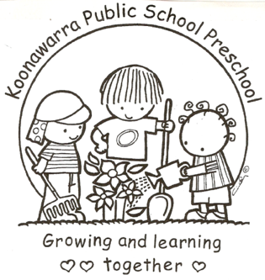
KOONAWARRA PUBLIC SCHOOL PRESCHOOL

(f) Delivery and collection of children

Current | July 2018
Next Review | July 2019
Regulation(s) | Regulation 99  Regulation 168
National Quality Standard(s) | Standard 2.1  Standard 2.2  Standard 6.1  Standard 6.2
Relevant DoE Policy and link | Student Health in NSW Public Schools: A summary and consolidation of policy PD/2004/0034/V01  Public Schools NSW: Protecting and Supporting Children and Young People Policy  Public Schools NSW Preschool – Obtaining parents’ authorisation and consent procedures  Public Schools NSW: Application to enrol in a NSW government preschool
Relevant School Procedure
DoE Preschool Handbook January 2016 | Department of Education Preschool Handbook:  Wellbeing, pp. 39 – 40.  Wellbeing - Appendix 2.5 pg. 50 - Preschool Arrival and Departure Register  Wellbeing - Appendix 2.6 pg. 51 - Preschool Arrival and Departure Procedures
Key Resources
Forbes Street Woolloomooloo 2013
T: 9358 5335/6
F: 93571831
E: plunketstr-p.school@det.nsw.edu.au

- The Education and Care Services National Regulations (regulations 99 &158) require that staff pay attention to the arrival and departure of children in the preschool to ensure their safety.

- Children will not be admitted into the Preschool before 8.40am

- Children will be brought to and collected from the preschool by a parent or other person who is authorised in writing by the parent to collect the child.

- Children will not be left in the preschool grounds without adult supervision.

- Preschool educators will receive the children directly from their parents, or other authorised person, and are not to release them into the care of any unauthorised person. If an unknown person is unable to prove their identity, and is seeking to collect a child, the principal and/or the child’s parent will be contacted to see advice.

- If a parent or guardian verbally informs the preschool of a new authorised person, the educator records this information on the ‘Collection of Children Authorisation’ form. This is later updated in the child’s records. See class folders in the kitchen.

- At the end of each day, educators will check all areas to ensure that no child remains on the premises. Both staff will check the sign in and out register to ensure all children have been signed out. Each educator will sign at the bottom of the sheet to indicate that these tasks have been carried out.

- An arrival and departure register will be kept in the preschool room and will be signed by parents or a person with authorisation, when delivering or collecting a child. This record of attendance meets the requirements of Regulation 158(1):

- Records the full name of each child attending the service
- Records the date and time each child arrives and departs
- Is signed by parents or authorised person delivering or collecting a child
- Is signed by the preschool teacher and the SLSO.

- If a parent or authorised person forgets to sign their child in or out, an educator will sign in lieu and get the parent to initial this entry on their next visit.

- If a child hasn’t been picked by 2.50pm the preschool staff will contact parents/ authorised persons to organise pick up.

- This register will be kept in secure storage until the child reaches 25 years of age.

