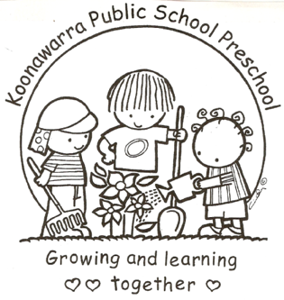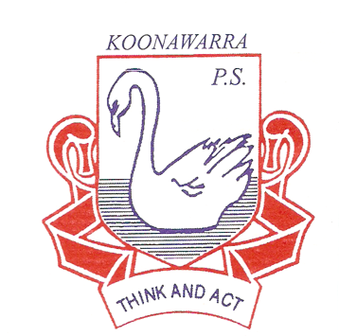
KOONAWARRA PUBLIC SCHOOL PRESCHOOL

(c) Dealing with infectious diseases

Current | 25/6/2018
Next Review | June 2019
Regulation(s) | Regulation 88  Regulation 77  Regulation 168 (2)(a)
National Quality Standard(s) | Standard 2.1  Standard 2.2  Standard 3.1
Relevant DoE Policy and link | Student Health in NSW Public Schools: A summary and consolidation of policy PD/2004/0034/V01  Public Schools NSW: Infection Control Information  Public Schools NSW: Infection Control Procedures  Public Schools NSW: Infectious Diseases information
Relevant School Procedure
DoE Preschool Handbook January 2016 | Department of Education Preschool Handbook :  Wellbeing pg. 27-29; 32  Wellbeing Appendix 2.1  Standard precautions for infection control  Appendix 2.2  Breathing, Blowing, Coughing Program (BBC Program)  Wellbeing Appendix 2.3  Nappy changing and other toileting procedures  Wellbeing Appendix 2.4  A good practice guide for spilt urine or faeces and cleaning children after wetting or soiling themselves
Key Resources | Public Schools NSW: Health and Safety Directorate  Public Schools NSW: Incident Reporting Information  Staying Healthy in Childcare 5th Edition
Hand washing
- Children are required to wash their hands at regular intervals throughout the preschool day. These times are outlined below;
- before and after any meal time or contact with food
- after going to the bathroom
- after patting or touching animals
- after coughing, sneezing or wiping their nose

- Adults are also required to wash their hands at the same regular intervals throughout the day, but more, including;
- before and after assisting children with toileting
- before and after administering first aid or medication
- before and after preparing or handling food
- after wiping a child's nose
- after coming into contact with bodily fluids
- before and after applying sunscreen

- Children are taught hand washing procedures at the start of the year and reminded throughout each day of the importance of this hygiene practice.

- Posters are displayed in the bathroom and kitchen areas as a visual prompt to remind children and staff of the correct hand washing procedures.

- Staff model correct hand washing practices at the appropriate times and monitor children throughout the day.

- Individual hand towels are used to ensure an avoidance of cross contamination.

Toileting
- Parents have the responsibility of toilet training, however at preschool age children are still developing toileting habits, so it is appropriate for staff to support parents during this process. Parents are encouraged to inform staff of any toileting difficulties.

- If a child has a soiling or wetting accident, educators are to wash hands, wear gloves and assist the child as best they can. Soiled or wet clothing should be placed in a tied bag in the laundry so they are inaccessible to children. Parents are to be notified upon collection and can retrieve the bag of soiled clothing to take home. Parents are asked at the beginning of the year, to ensure spare clothes are available in the child’s bag. If there are no spare clothes the educators will contact the school office to supply appropriate clothes.

- Gloves, baby wipes and paper towel will be placed in a bag in the outside bin.

- Posters are displayed in the bathroom as a visual prompt to remind children and staff of the correct toileting procedures. Encouraging children to be independent in these areas is essential and staff should model and teach appropriate hygiene practices.

- We have shower facilities in the bathroom in case the need arises for showering a child due to soiling. If a child enrols in the preschool who has a medical condition or disability and wears nappies, a nappy changing area must be made available in the bathroom. Nappies will be placed in a bag in the outside bin.

Cleaning
- Spray bottles with disinfectant are available. These are used with correct colour cloth for each task to prevent cross-contamination. Tabletops are cleaned before and after each session. A mop and bucket are available to clean the floor with detergent and hot water when children have a toileting accident.

- DoE preschools have contracted cleaners who clean the floors and bathrooms daily. More extensive cleaning is conducted during school holidays, such as cleaning the rafters and windows of our preschool.

- Soft toys, dress up clothing, puzzles, books, sand equipment, tables and chairs and indoor equipment are cleaned regularly to reduce the spread of infection.

Sandpit
- The sand pit should be securely covered when not in use to prevent contamination from animal excreta, broken glass and other objects. The sandpit should be checked daily to remove any contaminated objects.

- The sandpit should be kept within 100mm of the top edge, renewed as necessary and cleaned periodically. (Cleaning can be achieved through a number of methods which are documented in the Preschool Handbook).

Infectious Disease Outbreak
All children MUST provide evidence of immunisation status before being allowed to enrol in our Preschool. The Medicare immunisation schedule should be presented at time of enrolment. Conscientious objectors can no longer enrol their children in child care and will need to make alternative arrangements. The only unimmunised children who can be enrolled in child care after 1 January 2018 are those who are on a recognised catch-up schedule (provided that the appropriate documentation has been provided), or those who are unimmunised due to medical reasons

- If a child is suspected of having an infectious disease whilst at preschool, the child's parents will be contacted to collect their child from preschool. The child will be isolated from other children, made comfortable and supervised by a staff member until they are collected.

- Some infectious diseases require children to be excluded from attending preschool (these exclusion periods are outlined in the NSW Health Guidelines and Staying Healthy Guide 5th Edition)
.
- Preschool staff will notify the principal who will contact notify State Early Learning Team and the nearest public health unit if necessary. In the event that the principal is not contactable the preschool staff will notify State Early Learning Team on 9266 8165. The preschool teacher will contact parents. Notification will also need to be made to the regulatory authority ACECQA through the DoE Early Learning Team.

- In the event of an outbreak of an infectious disease, all families will be notified. An infectious diseases notice will be displayed in the preschool and a fact sheet sent home and/or emails. This fact sheet will outline the symptoms, treatments and exclusion periods of the infectious disease.

- All families of children who are not immunised (conscientious objectors or not immunised for medical reasons) will be notified immediately of an infectious disease outbreak.

- The following website provides quick access to infectious diseases fact sheets for families when required: http://www.health.nsw.gov.au/Infectious/factsheets/Pages/default.aspx

