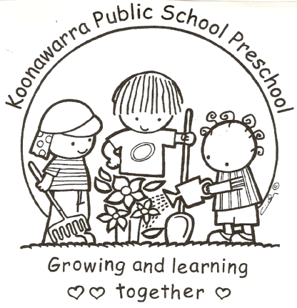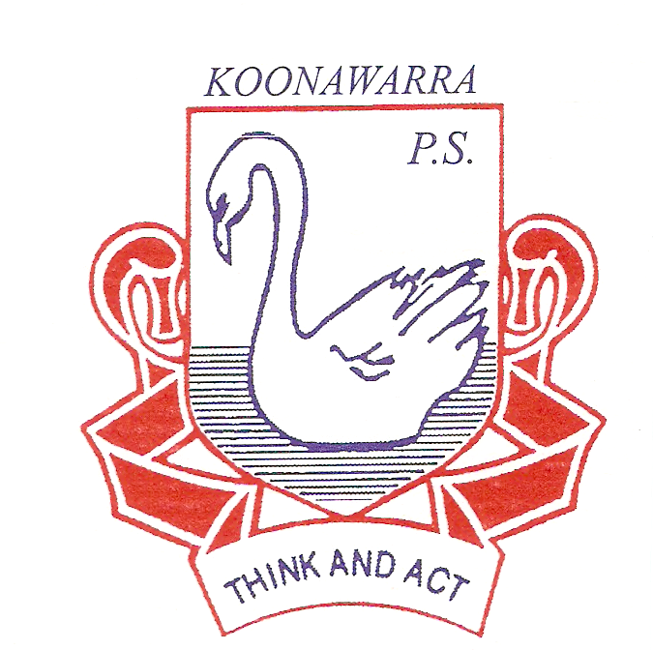
KOONAWARRA PUBLIC SCHOOL PRESCHOOL

Environmental Sustainability Strategy
National Quality Standards
QA3 3.2.3 – Environmentally responsible
QA6 6.2.3 – Community Engagement

EYLF
Outcome 2 – Children are connected with and contribute to their world.

Aim
Our service aims to help children learn about and implement sustainable practices and foster respect and care for the living and non-living environment.

Implementation
Children develop positive attitudes and values about sustainable practices by engaging in learning experiences, joining in discussions that explore solutions to environmental issues, and watching adults model sustainable practices. Children learn to live interdependently with the environment.

Environmental Sustainability and our Curriculum
Our educators will promote an holistic, open ended curriculum which explores ideas and practices for environmental sustainability and helps children understand the interdependence between people and the environment by:

o connecting children to nature through art and play and allowing children to experience the environment through natural materials like wood, stone sand and recycled materials, plants including native vegetation, a digging patch with gardening tools and watering cans.
o developing education programs for water conservation, energy efficiency and waste reduction.
o celebrating childrens’ environmental knowledge and sustainable activities.
o involving children in nature walks, education about plants and gardening and growing plants and flowers from seed.
o engaging children in learning about the food cycle by growing, harvesting, and cooking food for our service kitchen.
o using resource kits and information on environmental issues or resources targeted at early childhood services such as “The Little Green Steps” Resource kits on Water, Waste and Wildlife.
o enlisting the help of groups with expertise in environmental issues, to deliver elements of our sustainability program (Wollongong Council)
o acknowledging and celebrating environmental awareness events like Clean Up Australia Day and Walk to School Day.

The Role of Educators
Our educators will model sustainable practices by embedding sustainability into all aspects of the daily running of our service operations including:
o recycling materials for curriculum and learning activities
o minimising waste and effectively using service resources
o turning off equipment when not in use
o using the least hazardous cleaning substance appropriate for the situation, for example, ordinary detergent for cleaning dirt from tables and other surfaces.
o composting
o maintaining a worm farm
o maintaining a vegetable/herb garden
o incorporating water wise strategies such as water tank, manual water pump, and ensuring taps are turned off and leaks fixed.
o using food that we have grown in cooking experiences and for morning tea.

Partnerships with Families and the Community
Our educators will facilitate collaborative partnerships with local community groups (Men’s Shed), government agencies and private companies (Bunnings, Wollongong Council) to enhance and support childrens’ learning about sustainable practices. Families will be encouraged to participate in information sharing about environmental sustainability through our newsletters, wall displays, and meetings.
Source
National Quality Standard
Early Years Learning Framework Climbing the little green steps 2007: Gosford and Wyong Councils
NSW Early Childhood Environmental Education Network
Review
The policy will be reviewed annually.

Last reviewed: August 9, 2018
Next Review: August 2018

