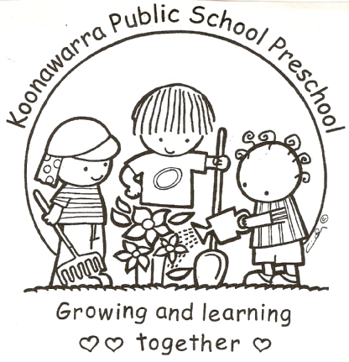
KOONAWARRA PUBLIC SCHOOL PRESCHOOL

At access the National Early Childhood Regulation and Care Regulation
Please go to
https://www.legislation.nsw.gov.au/#/view/regulation/2011/653

To access the associated NSW Department of Education policies please go to the following link.
https://education.nsw.gov.au/teaching-and-learning/curriculum/preschool/policy-and-procedures

