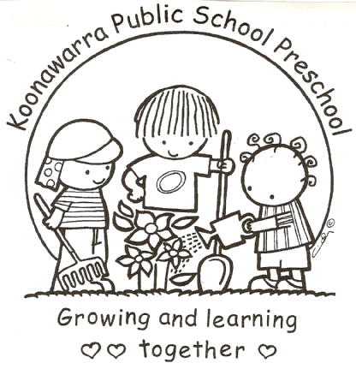
KOONAWARRA PUBLIC SCHOOL PRESCHOOL

Preschool Fees Agreement

Procedures:

- Parents are required to pay a fee for attendance of their child at Preschool
- There is provision for fee relief.
- Fees will be set according to the DEC policy and may be adjusted by DEC annually, in accordance with the Index of Community Socio-Economic Advantage (ICSEA).
- On enrolment parents who wish to apply for fee relief must present an original Health Care Card for verification by the Principal. Updated cards need to be presented to Preschool staff during the course of the child’s attendance.
- Staff are required to ensure the Health Care Card is current.
- Where fees are outstanding the Principal should make contact with the parent within one month to work out a plan for fee recovery.
- Failure to settle outstanding fees can jeopardise the child’s position, and the consideration for enrolment of siblings in the future.

I agree to:

Pay the required fees whilst my child is in attendance at Koonawarra Public School Preschool.

Let Carol Williams, Teacher/Director or Principal know if I am having difficulty paying or require fee relief.

I understand that if I fail to settle outstanding fees my child’s position can be forfeited and/or future sibling enrolments will not be considered.

________________________________ ___________________________ ____________

Name Signature Date

Reviewed August 2017

