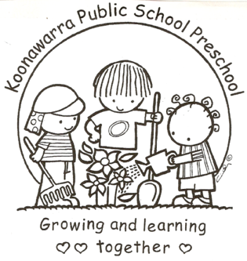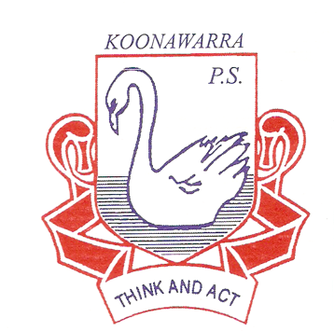
KOONAWARRA PUBLIC SCHOOL PRESCHOOL

Menu

Forbes Street Woolloomooloo 2013
T: 9358 5335/6
F: 93571831
E: plunketstr-p.school@det.nsw.edu.au

At Koonawarra Public School Preschool, we provide the following meal time foods:

9.30 am – toast with margarine and sometimes Vegemite (this is made in the Breakfast Club);

11. am (morning tea) – fruits, cheese, deli meats and a cup of light milk.

