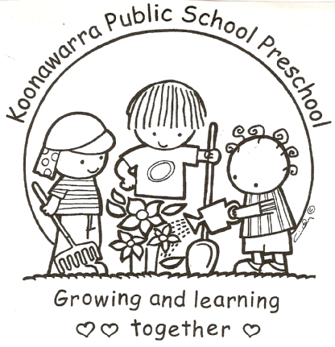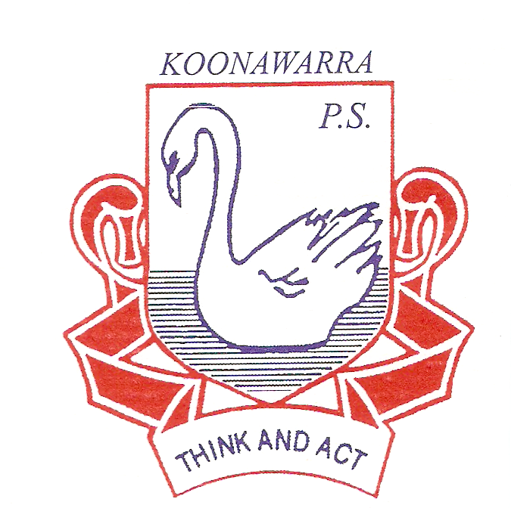
KOONAWARRA PUBLIC SCHOOL PRESCHOOL

Medical Conditions

Policy

Koonawarra Preschool will implement best practice risk minimisation strategies to ensure appropriate identification and management of any persons identified as at risk of a medical condition that has the potential to escalate to a medical emergency. This includes the provision of suitable first aid training and competencies to all staff to ensure a rapid response in the event of a person experiencing a medical condition that escalates to a medical emergency.

The aim of this Policy is to:
- Minimise the potential risk that may arise from any medical condition, including anaphylaxis that could adversely affect the health, safety and wellbeing of any person enrolled or employed at ? Preschool.
- Ensure the identification of at risk children upon enrolment including implementation of best practice risk minimisation strategies for any child identified as at risk of a medical condition that has the potential to escalate to a medical emergency.
- Ensure all centre staff have adequate knowledge of allergies, anaphylaxis and emergency procedures to ensure the immediate response in the event of a person experiencing anaphylaxis or allergic reaction by initiating appropriate treatment, including administering an adrenaline auto-injection device (i.e. EpiPen® or Anapen®)

Relevant Legislation: Children (Education and Care Services National Law Application) Act 2010; Education and Care Services National Regulations 2016; Guide to the National Quality Standard (3)

Sources: Goodstart Early Learning Medical Conditions Policy (2015) and Kardinia Childcare and Kindergarten Medical Conditions Policy (2016).

Procedures:

Nominated Supervisor and Educators will ensure that:
- A medical management plan is provided for any child enrolled at the service with a specific health care need, allergy or relevant medical condition, which is to be followed in the event of an incident relating to the specific health care need, allergy or relevant medical condition. The medical management plan will also include a risk minimisation plan.
- They are using a child’s Medical Management Plan, and that they will develop a Medical Conditions Risk Minimisation Plan in consultation with a child’s parents.
- The Medical Conditions Risk Minimisation Plan identifies and addresses any potential risks and minimises these.
- The plan be developed with the child’s parents and medical professionals and these individuals inform the Medical Conditions Risk Minimisation Plan.
- The communication plan enables all centre staff (including contractors, volunteers and students) to be informed about the medical management policy, medical management plan and risk minimisation plan for the child/person. The plan will also enable all centre staff (including volunteers and students) can identify the child/person and the location of their medication.
- They promote consistency and the welfare of all children using the service, by following all health, hygiene and safe food policies and procedures.
- Any allergens that may be present at the service will be communicated to parents and addressed through the Medical Conditions Risk Minimisation Plan.
- Whilst developing the Medical Conditions Risk Minimisation Plan and to minimise the risk of exposure of children to foods that might trigger severe allergy or anaphylaxis in susceptible children, the service will consider and implement the following:
  - While not common, anaphylaxis is life threatening. Anaphylaxis is a severe allergic reaction to a substance. While prior exposure to allergens is needed for the development of true anaphylaxis, severe allergic reactions can occur when no documented history exists.
  - Be aware that allergies are very specific to the individual and it is possible to have an allergy to any foreign substance.
  - Anaphylaxis can be caused by insect bites such as bees or wasps but is usually caused by a food allergy. Foods most commonly associated with anaphylaxis include peanuts, seafood, nuts and, in children, eggs and cow’s milk.
  - Other common groups of substances which can trigger allergic reaction or anaphylaxis in susceptible children include:
    - All types of animals, insects, spiders and reptiles.
    - All drugs and medications, especially antibiotics and vaccines.
    - Many homeopathic, naturopathic and vitamin preparations.
    - Many species of plants, especially those with thorns and stings.
    - Latex and rubber products.
    - Band-Aids, Elastoplast and products containing rubber based adhesives.

- Educators should be on the lookout for symptoms of an allergic reaction, as per their training. Educators should be on the lookout for symptoms as they need to act rapidly if they do occur. Educators should immediately call 000 if symptoms arise. If you know an educator or child is prone to anaphylaxis reactions, and they carry an EpiPen® or AnaPen® it should be injected by an educator trained in first aid. CPR (from a trained First Aid Officer) should be initiated should the educator or child stop breathing.
- The following steps be taken to prevent anaphylaxis occurring as outlined below:
  - Upon enrolment, seek medical information from parents about any known allergies. Ask parents for supporting documentation as well as a Medical Management Plan. This Medical Management Plan should include a photo of the child, what triggers the allergy, first aid needed and contact details of the doctor who has signed the plan. This should be kept on the child’s enrolment file and also be displayed in the service, in an area where all educators can easily access near a telephone. A copy should also be kept where the child’s medication is stored. If the child is taken on an excursion, a copy of the management plan should be taken on the excursion. Should a child be known to have allergies requiring medication if a reaction occurs, the parents will be asked to provide the medication. Furthermore, should the child’s treatment change, families are asked to provide the service with a new Medical Management Plan from their child’s medical practitioner. Documentation will then be updated at the service.
- If displaying personal information about children’s or staff member’s allergies in food preparation or serving areas, do so in accordance with privacy guidelines, such as displaying in an area accessible to staff and not accessible to visitors or other families. Explain to families the need to do so for purpose of safety of the child and obtain parental consent.
- Risk minimisation practices are carried out so that the service can provide an environment that will not trigger an anaphylactic reaction in a child. These practices will be documented and reflected upon, with any practice that may be discovered amended to decrease risk. For example, a procedure to ensure that the child is never at the service without their EpiPen or AnaPen or relevant medication.
- The service will display an Australasian Society of Clinical Immunology and Allergy inc (ASCIA) generic poster called Action Plan for Anaphylaxis in a key location at the service, for example, in the children’s room, the staff room or near the medication cabinet
- Ensure that no child who has been prescribed an adrenaline auto-injection device is permitted to attend the service or its programs without the device.
- They develop an ongoing communication plan with the child’s parents and with educators at the service to ensure that all relevant parties are updated on the child’s treatment, along with any regulatory changes that may change the service’s practices in regards to anaphylaxis.
- They provide support and information to the service’s community about resources and support for managing allergies and anaphylaxis.
- The service’s auto-injection device kit is stored in a location that is known to all staff, including relief staff; easily accessible to adults (not locked away); inaccessible to children; and away from direct sources of heat.
- Routinely, the service will review each child’s medication to ensure it hasn’t expired.
- The service will not allow children to trade food, utensils or food containers.
- Ideally, children who have severe allergies should only be served food prepared at their homes. If it is decided that the child will have food prepared for them at the service, this will be prepared in line with their management plan and family recommendations.
- The service will use non-food rewards with children. For example, stickers for appropriate behaviour.
- Families are requested to label all bottles, drinks and lunchboxes etc with the child’s name that they are intended for.
- The use of food products in craft, science experiments and cooking classes may need to be changed in order to allow children with allergies to participate.
- Food preparation staff will be instructed on the necessity to prevent cross contamination.
- Parents will be asked not to send food with their children that contain high allergenic elements even if their child does not have an allergy. For example, a sign in the foyer reminding families not to send food with high allergenic elements to the service even if their child doesn’t have an allergy.
- If appropriate, a child with allergies may have to sit at a different table if food is being served that he/she is allergic to. This will always be done in a sensitive manner so that the child with the allergy does not feel excluded. If a child is very young, the family may be asked to provide their own high chair to further minimise the risk of cross infection.
- When the child diagnosed at risk of anaphylaxis is allergic to milk, non-allergic babies will be held when they drink formula/milk.
- Where possible, ensure all children with food allergies only eat food and snacks that have been prepared for them at home.
- Restrict the use of foods likely to cause allergy in craft and cooking play.
- Always follow correct health, hygiene and safe food policies and procedures.
- Food preparation personnel (staff and volunteers) should be instructed about measures necessary to prevent cross contamination between foods during the handling, preparation and serving of food – such as careful cleaning of food preparation areas and utensils.
- All children need to be closely supervised at meal and snack times and consume food in specified areas. To minimise risk children will not be permitted to ‘wander around’ the service with food.
- Meals prepared at the service should not contain ingredients such as milk, eggs or nuts.
- Any body lotions, shampoos and creams used on allergic children have been approved by their parent.
- Where a child is known to have a susceptibility to severe allergy or anaphylaxis to a particular food, the service will have a “allergy-awareness policy” for that particular food, (e.g. a “Allergy-Aware (Nut) Policy”), which would exclude children or other individuals visiting the service from bringing any foods containing nuts or nut products such as :
  - Peanuts, brazil nuts, cashew nuts, hazelnuts, almonds, pecan nuts.
  - Any other type of tree or ground nuts, peanut oil or other nut based oil or cooking product, peanut or any nut sauce, peanut butter, hazelnut spread, marzipan.
  - Any other food which contains nuts such as chocolates, sweets, lollies, nougat, ice creams, cakes, biscuits, bread, drinks, satays, pre-prepared Asian or vegetarian foods.
  - Foods with spices and seeds such as mustard, poppy, wheat and sesame seeds.
  - Nut and peanut material is also often in cosmetics, massage oils, body lotions, shampoos and creams such as Arachis oil.

- They are aware that a child may have a number of food allergies or there may be a number of children with different food allergies, and it may not be possible to have an allergy free policy for all those foods involved. Nut allergy is the most likely to cause severe reaction and should take precedence.
- In the situation where a child who has not been diagnosed as allergic, but who appears to be having an anaphylactic reaction, staff will:
  - Call an ambulance immediately by dialling 000.
  - Commence first aid measures.
Contact the parent/guardian.
  - Contact the person to be notified in the event of illness if the parent/guardian cannot be contacted.

- All educators be trained to recognise how serious anaphylaxis is and undertake the steps that need to be taken in order to minimise the possibility of occurrence. The service will maintain the following in relation to educator qualifications for anaphylaxis:
  - The service will ensure that all educators have completed first aid and anaphylaxis management training that has been approved by the Director at least every three years from the date their qualification was issued.
  - The service will ensure that all educators in all services whether or not they have a child diagnosed at risk of anaphylaxis undertakes training in the administration of the adrenaline auto-injection device and cardio- pulmonary resuscitation every 12 months.
  - The service will also ensure that all relief educators used by the service adhere to these qualification requirements.

Revised September 2016

