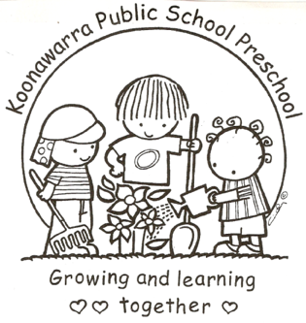
KOONAWARRA PUBLIC SCHOOL PRESCHOOL

(f) Delivery and collection of children

Forbes Street Woolloomooloo 2013
T: 9358 5335/6
F: 93571831
E: plunketstr-p.school@det.nsw.edu.au

Current | May 25, 2017
Next Review | May 2018
Regulation(s) | R. 99, 158, R168
National Quality Standard(s) | Element 2.3.2: Every reasonable precaution is taken to protect children from harm and any hazard likely to cause injury.  Element 7.3.2: Administrative systems are established and maintained to ensure the effective operation of the service.
Relevant DoE Policy and link | Student Health in NSW Public Schools: A summary and  consolidation of policy  https://education.nsw.gov.au/policy-library/policies/student-health-in-nsw-public-schools-a-summary-and-consolidation-of-policy  Protecting and Supporting Children and Young People Policy  https://education.nsw.gov.au/policy-library/policies/protecting-and-supporting-children-and-young-people-policy
Relevant School Procedure
DoE Preschool Handbook January 2016 | Wellbeing, page 39  Wellbeing Appendix, 2.6 Arrival and departure procedures
Key Resources

- The Education and Care Services National Regulations (regulations 99 &158) require that staff pay attention to the arrival and departure of children in the preschool to ensure their safety.

- Children will not be admitted into the Preschool before 8.40am

- Children will be brought to and collected from the preschool by a parent or other person who is authorised in writing by the parent to collect the child.

- Children will not be left in the preschool grounds without adult supervision.

- Preschool educators will receive the children directly from their parents, or other authorised person, and are not to release them into the care of any unauthorised person. If an unknown person is unable to prove their identity, and is seeking to collect a child, the principal and/or the child’s parent will be contacted to see advice.

- If a parent or guardian verbally informs the preschool of a new authorised person, the educator records this information on the ‘Collection of Children Authorisation’ form. This is later updated in the child’s records.

- At the end of each day, educators will check all areas to ensure that no child remains on the premises. Both staff will check the sign in and out register to ensure all children have been signed out. Each educator will sign at the bottom of the sheet to indicate that these tasks have been carried out.

- An arrival and departure register will be kept in the preschool foyer and will be signed by parents or a person with authorisation, when delivering or collecting a child. This record of attendance meets the requirements of Regulation 158(1):

- Records the full name of each child attending the service
- Records the date and time each child arrives and departs
- Is signed by parents or authorised person delivering or collecting a child
- Or signed by the nominated supervisor or preschool teacher
- For children travel by bus they are signed in and out by educators

- If a parent or authorised person forgets to sign their child in or out, an educator will sign in lieu and get the parent to initial this entry on their next visit.

- If a child hasn’t been picked by 3pm they child will accompany the teacher to the school office for collection.

- This register will be stored on site for three years in a locked filing cabinet, and kept in secure storage until the child reaches 25 years of age.

