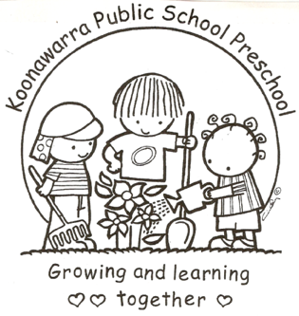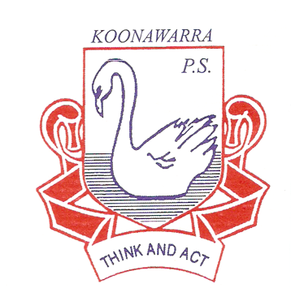
KOONAWARRA PUBLIC SCHOOL PRESCHOOL

(c) Dealing with infectious diseases

Forbes Street Woolloomooloo 2013
T: 9358 5335/6
F: 93571831
E: plunketstr-p.school@det.nsw.edu.au

Current | May 24, 2017
Next Review | May 2018
Regulation(s) | R.88; R.77; R168
National Quality Standard(s) | Element 2.1.3: Effective hygiene practices are promoted and implemented.  Element 2.1.4: Steps are taken to control the spread of infectious diseases and to manage injuries and illness, in accordance with recognised guidelines.  Element 6.3.1: Links with relevant community and support agencies are established and maintained.
Relevant DoE Policy and link | Student Health in NSW Public Schools: A summary and consolidation of policy PD/2004/0034/V01  Related Documents:  Injury management, health and wellbeing – includes first aid and infection control (Health and Safety Directorate - intranet only)  Student Safety (Health and Safety Directorate - intranet)
Relevant School Procedure
DoE Preschool Handbook January 2016 | Wellbeing, p. 27-29, 31, 33  Wellbeing Appendix 2.1  Standard precautions for infection control  Appendix 2.2  Breathing, Blowing, Coughing Program (BBC Program)  Wellbeing Appendix 2.3  Nappy changing and other toileting procedures  Wellbeing Appendix 2.4  A good practice guide for spilt urine or faeces and cleaning children after wetting or soiling themselves
Key Resources | Staying Healthy in Child Care - Preventing infectious diseases in child care (5th edition)

Hand washing
- Children are required to wash their hands at regular intervals throughout the preschool day. These times are outlined below;
- before and after any meal time or contact with food
- after going to the bathroom
- after patting or touching animals
- after coughing, sneezing or wiping their nose

- Adults are also required to wash their hands at the same regular intervals throughout the day, but more, including;
- before and after assisting children with toileting
- before and after administering first aid or medication
- before and after preparing or handling food
- after wiping a child's nose
- after coming into contact with bodily fluids
- before and after applying sunscreen

- Children are taught hand washing procedures at the start of the year and reminded throughout each day of the importance of this hygiene practice.

- Posters are displayed in the bathroom and kitchen areas as a visual prompt to remind children and staff of the correct hand washing procedures.

- Staff model correct hand washing practices at the appropriate times and monitor children throughout the day.

- Individual hand towels are used to ensure an avoidance of cross contamination.

Toileting
- Parents have the responsibility of toilet training, however at preschool age children are still developing toileting habits, so it is appropriate for staff to support parents during this process. Parents are encouraged to inform staff of any toileting difficulties.
- If a child has a soiling or wetting accident, educators are to wash hands, wear gloves and assist the child as best they can. Soiled or wet clothing should be placed in a tied bag in the laundry so they are inaccessible to children. Parents are to be notified upon collection and can retrieve the bag of soiled clothing to take home. Parents are asked at the beginning of the year, to ensure spare clothes are available in the child’s bag. If there are no spare clothes the educators will contact the school office to supply appropriate clothes.
- Gloves, baby wipes and paper towel will be placed in a bag in the outside bin.
- Posters are displayed in the bathroom as a visual prompt to remind children and staff of the correct toileting procedures. Encouraging children to be independent in these areas is essential and staff should model and teach appropriate hygiene practices.
- We have shower facilities in staff bathroom in case the need arises for showering a child due to soiling. If a child enrols in the preschool who has a medical condition or disability and wears nappies, a nappy changing area is available in the staff bathroom. Nappy bins are stored in the staff toilet and these will be emptied according to health guidelines.
Cleaning
- Spray bottles with disinfectant are available. These are used with correct colour cloth for each task to prevent cross-contamination. Tabletops are cleaned before and after each session. A mop and bucket are available to clean the floor with detergent and hot water when children have a toileting accident.
- DoE preschools have contracted cleaners who clean the floors and bathrooms daily. More extensive cleaning is conducted during school holidays, such as cleaning the rafters and windows of our preschool.
- Soft toys, dress up clothing, puzzles, books, sand equipment, tables and chairs and indoor equipment are cleaned regularly to reduce the spread of infection.
Sandpit
- The sand pit should be securely covered when not in use to prevent contamination from animal excreta, broken glass and other objects. The sandpit should be checked daily to remove any contaminated objects.
- The sandpit should be kept within 100mm of the top edge, renewed as necessary and cleaned periodically. (Cleaning can be achieved through a number of methods which are documented in the Preschool Handbook).
Infectious Disease Outbreak
- NEW Immunisation rules for preschools – All children MUST provide evidence of immunisation status before being allowed to enrol in our Preschool. The Medicare immunisation schedule should be presented to the front office at time of enrolment. EXCEPTION – If in the case of a Medical or Conscientious objection to immunisation, a form stating the reasons for the objection must be completed by a General Practitioner and presented to the front office.
- If a child is suspected of having an infectious disease whilst at preschool, the child's parents will be contacted to collect their child from preschool. The child will be isolated from other children, made comfortable and supervised by a staff member until they are collected.
- Some infectious diseases require children to be excluded from attending preschool (these exclusion periods are outlined in the NSW Health Guidelines and Staying Healthy Guide 5th Edition).
- Preschool staff will notify the principal who will contact notify State Early Learning Team and the nearest public health unit if necessary. In the event that the principal is not contactable the preschool staff will notify State Early Learning Team on 9266 8165. The preschool teacher will contact parents. Notification will also need to be made to the regulatory authority ACECQA through the DoE Early Learning Team.

- In the event of an outbreak of an infectious disease, all families will be notified. An infectious diseases notice will be displayed in the preschool and a fact sheet sent home and/or emails. This fact sheet will outline the symptoms, treatments and exclusion periods of the infectious disease.
- All families of children who are not immunised (conscientious objectors or not immunised for medical reasons) will be notified immediately of an infectious disease outbreak.
- The following website provides quick access to infectious diseases fact sheets for families when required: http://www.health.nsw.gov.au/Infectious/factsheets/Pages/default.aspx

